Activity overview

In-class activity – Years 2 - 4

To Flush or Not to Flush

In this activity, students will investigate how we affect the sewage treatment process by reviewing what does and doesn’t belong down our toilets and drains by playing a game.

Curriculum links

Year 2 - Science
- Earth’s resources are used in a variety of ways (ACSSU032).
- People use science in their daily lives, including when caring for their environment and living things (ACSHE022) & (ACSHE035).

Year 4 – Science
- Natural and processed materials have a range of physical properties that can influence their use (ACSSU074).
- Science knowledge helps people to understand the effect of their actions (ACSHE051) & (ACSHE062).

Year 4 - HASS
- The use and management of natural resources and waste, and the different views on how to do this sustainably (ACHASSK090).

Time required
20 minutes.

Things you will need
- Watch the Unitywater video: The sewage treatment plant
- Open space, preferably on grass or carpet.
- Set of flush game activity cards – print enough sets for how many teams you will have playing. You may wish to print each set on a different coloured paper to help distinguish sets. (Activity card templates below.)
- Buckets, hoops or chalk to define disposal option location.
- Markers / witches hats to define starting line.

Activity outline
- Watch the Unitywater video: The sewage treatment plant
- Discuss the 3 Ps (pee, poo, paper) and questions students regarding what items should and shouldn’t be placed in the toilet and the reasons why.
- Discuss with students what should and shouldn’t go down the sink or drain and the reasons why.
- To help the discussion you may like to write the headings toilet, sink / drain, rubbish bin on the board. Use one set of the flush game cards to provide a list of items and as you discuss where the item should go place the cards under the appropriate heading on the board.
- Divide students into teams and place in lines at one end of the room. Provide each team with a set of flush game waste cards.
- At the opposite end of the room label three hoops / buckets with the toilet, sink / drain and rubbish bin label cards.
- Students take turns to select a waste card and place it the correct hoop / bucket at the other end of the room – either the toilet, sink/drain or rubbish bin – until all cards are sorted.
- Direct students how to move as they travel to place waste cards into hoops / buckets.
- As a group review what students have sorted into the various hoops / buckets and discuss cards which need to be moved and why.

Teacher Resource

To Flush or Not to Flush Activity Cards – labels

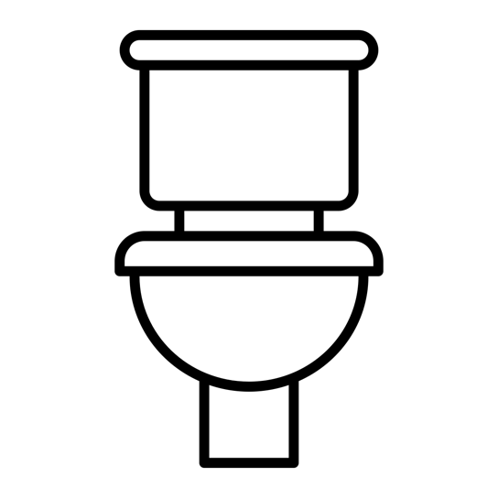
Toilet

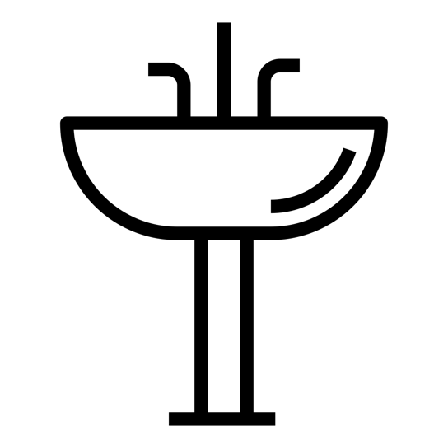
Sink /
Drain
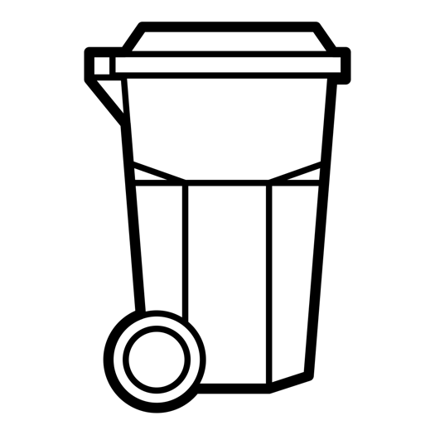
Rubbish
Bin

Activity sheet
To Flush or Not to Flush Activity Cards – waste cards

Disposable nappy | 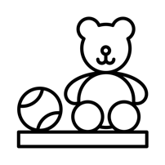  Toy | 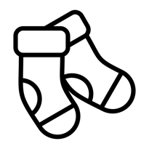  Sock
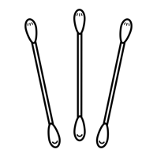  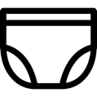  Cotton    bud | 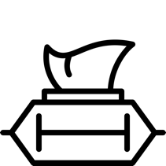  Wet  wipe | 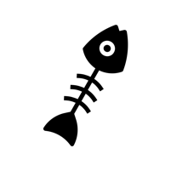  Food  scraps
Paint | 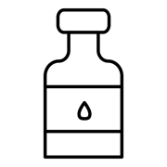  Chemicals | 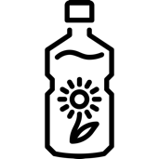  Cooking  oil
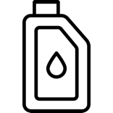  Engine  oil | 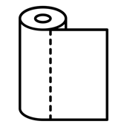  Paper  towel | Tissue
Goldfish | 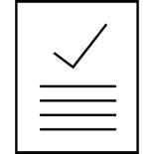  Homework | 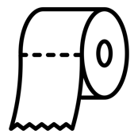  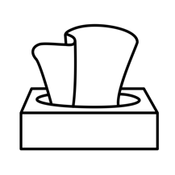  Toilet  paper
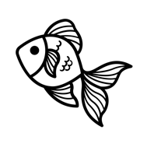  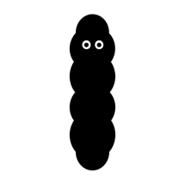  Poo  (faeces) | 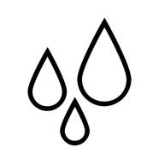  Pee  (urine) | 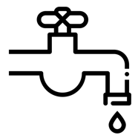  Hand  washing  water
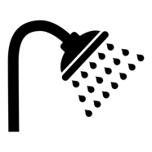  Shower  water | 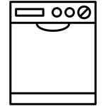  Dish-  washing  water | 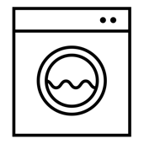  Washing machine  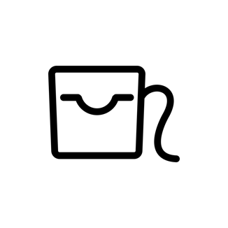  water
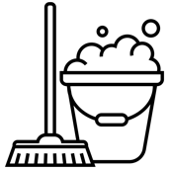  Mop  bucket  water |   Cotton  ball | Dental  floss

