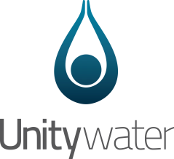
Certificate of Completion Without
Network Works
Accreditation and Certification
ABN: 89 791 717 472

South-East Queensland Water (Distribution and Retail Restructuring) Act 2009

Approval Details
Connection Approval No: [Enter Connection Approval Number]

Development Stage: [Enter Development Stage Number - If Applicable]
Street Address: [Street Address] [Suburb] [STATE] [Postcode]
Property Description: [Enter Lot and Plan Number/s]
Cancelling Lot/s: [Enter Lot/s being Cancelled]

Local Government Area: Select Local Government Area.

Certificate of Completion Issue Date: Click to Enter Date.

This certificate is given under section 99BRAR of the Act and confirms that the holder of the above listed connection approval has:
- Complied with the conditions of the approval; and
- Paid the fees and charges under the approval.

If you have any queries, please contact Unitywater at development.certification@unitywater.com or by phone on 1300 086 489.

Yours Sincerely

Delegated Officers Name - per the Instrument of Delegation.

Delegated Officers Title
Development Services

